

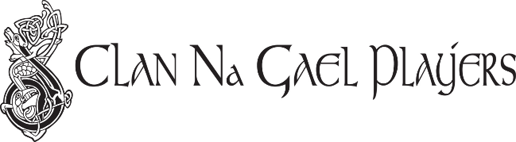

**Presenting Plays By Or About The Iris**

**ONE ACT PLAYWRIGHT CONTEST**

**2017 Instruction Form**

Clan Na Gael Players are pleased to announce the return of the One Act Playwright Contest. The purpose of the contest is to support and encourage emerging playwrights and to provide a stage for scripts that might not otherwise find one. Playwrights of all ages are encouraged to enter.

**The contest is seeking original One Act plays of not more than 20 minutes in length.**

**All entries must be the original writing of the submitting playwright.**

**They may be written in any style, set in any historical time, geographic or imaginary location and contain any number of characters.**

**Scripts are restricted to plays that have not been produced, published or won other contests.**

**Only one script per playwright will accepted.**

**Entries may be submitted by email to** [**Naoneil@charter.net**](mailto:Naoneil@charter.net) **starting March 15, 2017 and must be sent no later than August 15, 2017 to be considered.**

The Winners will be announced in September of 2017 and will receive a staged reading at the Gaelic-American Club on Sunday Afternoon, October 15, 2017.

**Each Script must include the following:**

**Page l - The play title only**

**Page 2 - A brief synopsis**

**List of characters including gender and age.**

**Note: Please do not include the playwright’s name in the script.** The playwright’s name is to be given on the Clan Na Gael Official Contest Submission Form which must be sent with the Script in a separate attachment. Please submit the script in WORD format. The Submission Form which requires the Playwright’s signature may be sent in PDF format.

The Clan Na Gael reserves the right to disqualify any scripts which do not adhere to the contest rules. By submitting your Script and Submission Form, you are granting The Clan Na Gael permission to distribute your script to the Judges and your submission information to those who will direct and perform your Play at the Reading should your script be selected as one of the winning plays to be performed.

The Clan Na Gael cannot guarantee but will use the upmost care in protecting your work by only sharing your

script and personal information with persons involved in this contest.

**To receive a submission form, please email** [**Naoneil@charter.net**](mailto:Naoneil@charter.net)**. Please contact Nancy O’Neil at (203) 377-1070 with any contest questions.**



**ONE ACT PLAYWRIGHT CONTEST**

**2017 Official Submission Form**

Playwright Last Name:

Playwright First Name:

Primary Contact Address:

Contact Phone Number(s)

E-Mail Address:

Play Title:

**If you are under 16 years of age please check here______**

By signing this form below you are acknowledging that the script being submitted is your own original work and that this script has not been produced, published or won other contests.

( the form should be electronically signed and emailed back)

________________ __________

Playwright’s signature Date signed

Please follow instructions completely in preparing and emailing your entry to [Naoneil@charter.net](mailto:Naoneil@charter.net). A confirmation of receipt of your entry will be sent to you by return email.

**Entries may be emailed starting March 15, 2017 and must be submitted no later than August 15, 2017 to be considered. Any contest questions, please call Nancy O’Neil at (203) 377-1070.**